User Personas

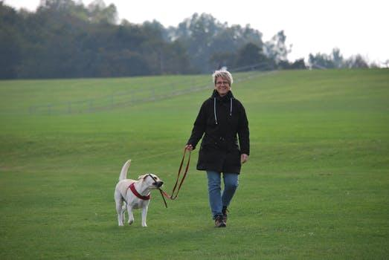

Marry

53, Therapist. Washington D.C.

Marry has been enjoying the outdoors with her dogs for as long as she can remember. When she isn’t working at her private practice, or taking care of her two sons, she is walking Tim in the neighborhood or taking him to the grocery store with her. She enjoys cooking, talking to friends, doing yoga, and spending time with her husband.

Goals: Marry wants to find a community of dog-lovers and help Tim make more friends! She would love to spend more time in parks with her community and all the pups.

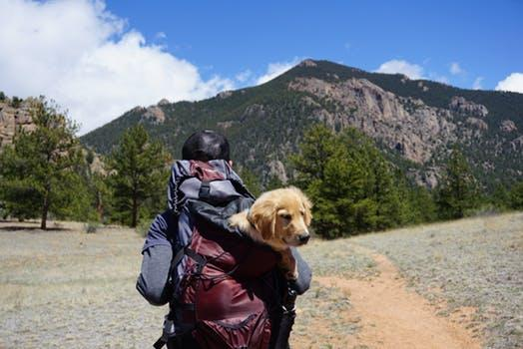

Kyle

34, Software Developer. Los Angeles

When Kyle and his dog get tired of the polluted LA air, they don’t think twice about making the weekend trip up to Yosemite national park. Kyle has a passion for life and loves to share every bit of it with his dog.

Goals: Kyle is looking for a community to meet up with people during his weekend get-aways